OS LAB 12

Name: rabia ID: FA17-BECE-2001

Task1:
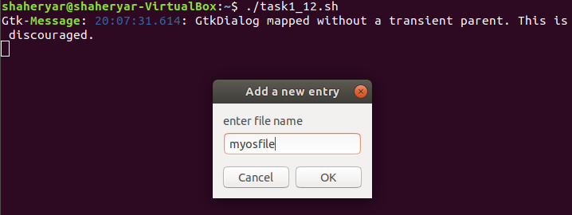
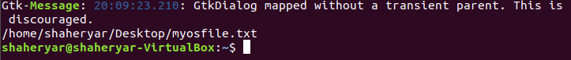
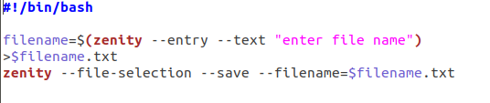

TASK2:

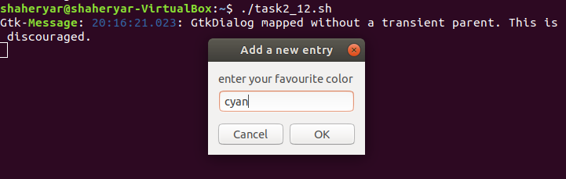
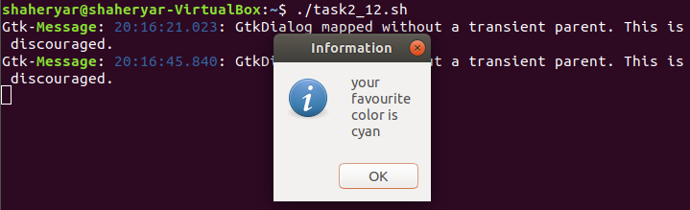
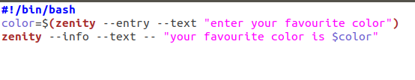
TASK3:

